1. **Name**: meitu
2. **Features**: It can beautify the photo and add some fancy filters. It also has some interesting features based on AI, such as transforming human photo into cartoon style. And it provides a new community, and you can post any footages you want on it. And you can download the latest materials in the material center.
3. **A. The main page**:

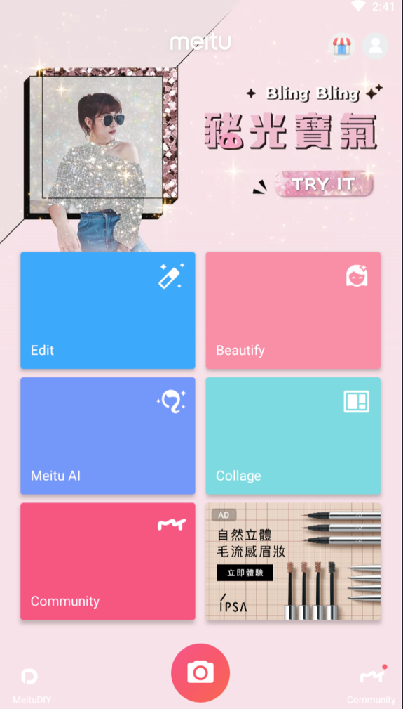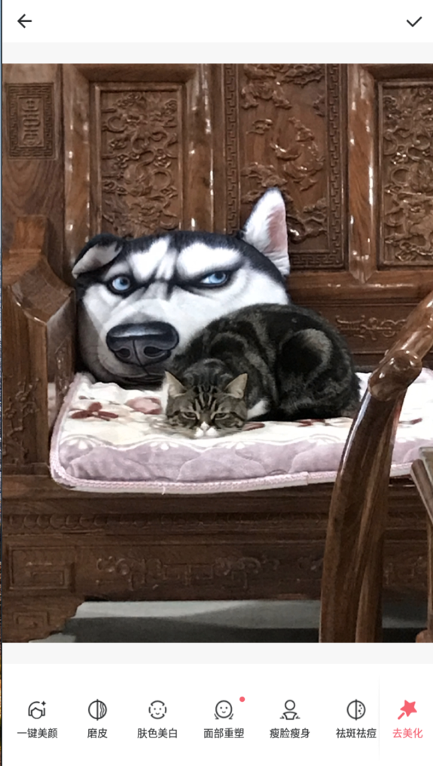

We can see some main features in this screenshot. Edit the photo, beautify the face, meitu AI, Collage, and Community. The last block is advertisement which is a part income from this app. From this, we can know that the target audience of this app is young ladies. And of course, the ads are for young ladies too. It also has an account system which is for the community feature. At the left-down corner, we can see the meituDIY Button in which you can make and buy cups and t-shirts printed your photo on it.

**B. The beautify page**

This is the most important feature in this app. Meitu has some excellent image processing method. They make everything much easier than Photoshop. Because it is a mobile app and face to normal users. They are not professional Photoshop users. For example, if you want to shrink your chin or make your face brighter, you just need to click the button and the app will detect your face and chin automatically. The Users do not need to spend time to learn how to use Photoshop , such as, liquid, sharp, etc. And It only spends a little time between taking the photo and post it on social network, instead of photoshop it on the computer.

And meitu also have a very interesting feature is that it can remember your edit setting, when you take a new photo you can use it on your photo automatically.

The page is normal and easy to use. The left-up corner of page is the back button, and the right-up corner of page is confirming button. The feature buttons are at the bottom of the page. The app our team going to develop is pretty similar to this page.

**C. the community page**



This page is similar to the other short-video app named “tik tok” .

In this page you can post some texts and photos by clicking the middle of bottom button. And the right-down button can fresh the community page. “recommended” can show you latest and most popular posts, and you can see the posts in the “following” page if you log on an account and followed somebody.

The target of this community is exactly the same as this app, they can post an learn making up and skills on editing photos from each other.

The is a new page added into meitu, it can make the usage-time longer, and the user engagement will be better.

1. **humanitarian potential:**

61% of meitu users age are between 18 and 35, and 81% of them are female. This app provides an excellent beautify tool box and community, they are user-friendly.

This app is totally free, so the majority of income is ad. And the most of download times is not happened in Google Play. However, we can find the number of users per mouth on website, it is about 349867k, which is 16% lower than the last year. Because some new beautify apps are released, they took some users from meitu.



In 2018 they build the community, and want to use it to get better usage-time. Because the longer users stay, the better for advertisement. In 2018, the income from advertisement has increased 244.8%, which means the community did have good effects for meitu. Meitu has already had his massive users, they can lead them to be a producer, which can post high-quality photos and posts.

The majority of users are creative and willing to share their lives, so it is a good chance to let them share them edited photo on meitu instead of WeChat or Weibo. So that meitu is not just a tool app, but a social app.

The biggest advantage of meitu is that it has a great tool box for beautify photos in social apps. The advertisement is also target to female between 18-35, such as cosmetic. So the most users are willing to click the advertisement.

1. **Functionality**

To compare the functionalities of meitu to other beautify apps, meitu can more choices to do. And you can choose different filters and effects.





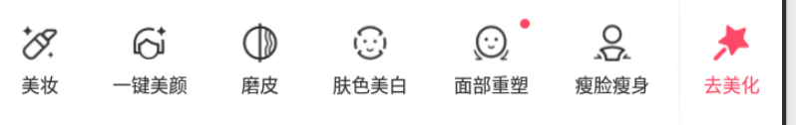

There are hundreds of effects and filters you can choose, and you can change the strength you like. And they also provide a series of face beautify tool box, you can modify your face in the way you like, or you can use one-click beautify function to make you face looked better.

You can also buy the clothes and cups, which are printed your photos.

They also provide a material market, you can download materials you want to use in your photo. There are filters, Mosaic, Frames, Stickers and Brushes.

**4. positive characteristics**

(1) meitu has high-quality graphic, the button and UI have good color and style

(2) The meituAI and community always have interesting effects and contents.

(3) meitu also has a wonderful tool box to beautify your photo. it is easy to use, and it work fast.

(4) It is hardly to find another tool app can do the same functions in only one app.

(5) The community has high-quality contents, the users are willing to spend time on it.

(6) Those image processing programs are efficient and useful.

1. **negative characteristics**
2. The functions are too many, which use too much storage and resources.
3. There are too many ads, and they are too split. They are looked too different with the other part of the app, such as the ad in main page.
4. Meitu also has too many functions, some of them are barely used. Maybe it can be designed like visual studio. The user can choose to install which functions. It can save the storage and resource when it is running.